# Checklist for Flow of work

* Use **Wiring Checklist** to plan your wiring between sensor and Arduino. Draw the wires between VCC, GND, SDA and SCL wires and write the color of jumper wire you plan to use in the respective columns in the table.
* Connect wires between LCD and Arduino as per your Wiring Checklist
* Connect Arduino to PC and start EzVid Screen Capture, start recording and Arduino IDE
* Is the **correct Board** - Arduino Genuino/Uno selected in Menu Item as shown below?

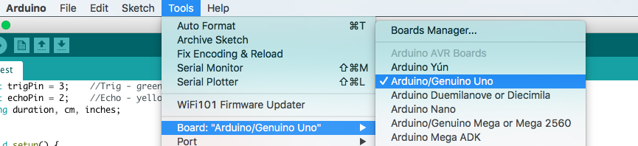

* **Is Correct port selected as shown below? THIS VARIES FROM PC TO PC, BUT ENDS WITH “ARDUINO/GENUINO UNO”**

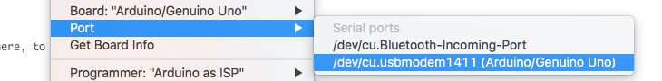

* Got the bus address
* Tested LCD if its connected by uploading the Liquid crystal PCF8574_Test
* Uploaded the Hello world sketch from Liquid crystal I2C library
* Verify and Upload sketch
* I can see the data on the LCD screen

**______________________________________________________________________________________**

# Troubleshooting

1. If you are not getting the output,
   1. Check wiring, maybe power pin is exchanged with gnd, maybe data pin is mapped to different pin in the code and different in your wiring.
   2. If backlight is not getting on, connect the 2 pins behind the LCD to each other.